**Project Design Phase-II**

**Solution Requirements (Functional & Non-functional)**

|  |  |
| --- | --- |
| Team ID | PNT2022TMID04459 |
| Project Name | Visualizing and Predicting Heart  Diseases with an Interactive Dashboard |

**Technical Architecture:**

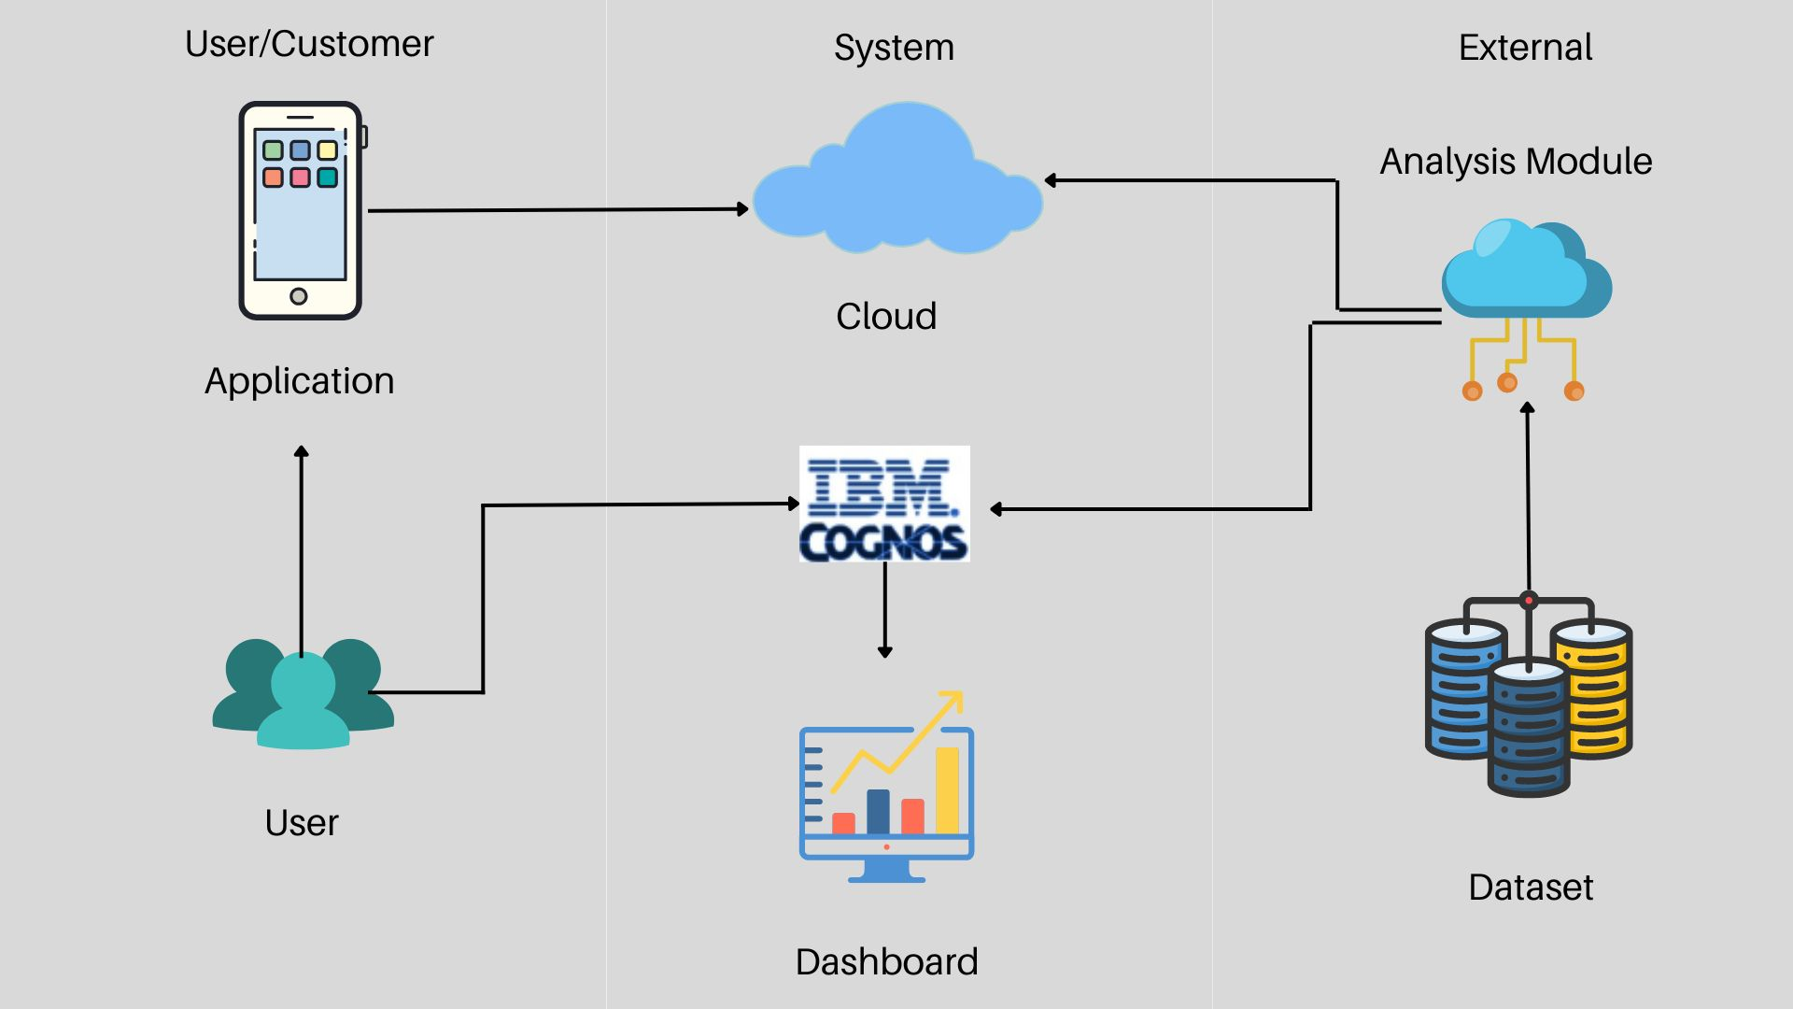

**Table-1 : Components & Technologies:**

|  |  |  |  |
| --- | --- | --- | --- |
| **S.No** | **Component** | **Description** | **Technology** |
| 1. | Importing data | Data Import allows you to upload data from other sources and combine it with data collected by Analytics. | Python , numpy , pandas |
| 2. | Data Cleaning | Data cleaning is a process by which inaccurate, poorly formatted, or noisy data are organised and corrected. | Python |
| 3. | Data Pre-processing | Data pre-processing is a component of data preparation, processing performed on raw data to prepare it for another data processing procedure is described | Python |
| 4. | Training data | Training data is the data you use to train an algorithm or machine learning model to predict the outcome you design your model to predict. | Python |
| 5. | Testing data | Test Data is data that is used to execute the tests on testware. Test data needs to be precise and exhaustive to uncover the defects. | Python |
| 6. | Machine learning model | A machine learning model is defined as a mathematical representation of the output of the training process. | Python |
| 7. | Improve model performance | For evaluating classification models accuracy is one of the metric. Informally, accuracy is the fraction of predictions our model got right | Python |
| 8. | Checking accuracy | A data accuracy check is a set of quality measures that take place before using data. | Python |

**Table-2: Application Characteristics:**

|  |  |  |  |
| --- | --- | --- | --- |
| **S.No** | **Characteristics** | **Description** | **Technology** |
| 1. | Open-Source Frameworks | A framework is a structure that you can build software on. It serves as a foundation, so you're not starting entirely from scratch. Frameworks are typically associated with a specific programming language and are suited to different types of tasks. Let's say you're building a house. You could pour the foundation and frame the house yourself. It would take a lot of time, but you could do it. If all of that were already done for you, though, it would save you quite a bit of effort especially if it was done by expert home builders. | Django |
| 2. | Security Implementations | SHA-1 or Secure Hash Algorithm 1 is a cryptographic hash function which takes an input and produces a 160-bit (20-byte) hash value. This hash value is known as a message digest. This message digest is usually then rendered as a hexadecimal number which is 40 digits long. | SHA-256, Encryptions, IAM Controls, OWASP |
| 3. | Scalable Architecture | Microservices architecture is an application structure that divides services into separate modules which are loosely coupled together, communicating with each other through light-weight mechanisms ,AMQP, HTTP resource API, WebSockets . | Microservices Smart Endpoints and Dumb Pipes, AWS Lambda, API Gateway |
| 4. | Availability | A load balancer is a technology that distributes high traffic sites among several servers using a network-based hardware or software-defined appliance. To ensure high availability and optimal service, the load balancer performs continual health checks of each server in the cluster, using probes to determine its eligibility for requests. | Server Load Balancers/ Global Service Load Balancing |
| 5. | Performance | In computing, a cache is a high-speed data storage layer which stores a subset of data, typically transient in nature, so that future requests for that data are served up faster than is possible by accessing the data's primary storage location. | Caching |